PHISHING EMAIL
ANALYSIS REPORT

Challenge 3 — Security Operations Centre — Global Logistics

ENVIRONMENT | Kali Linux + Sublime Text
FILE | challenge3.eml
MODULE | 01_Phishing_Analysis / Challenges: SOC 101 Course Challenges
CLASSIFICATION | Incident Analysis — Phishing
STATUS | Under Investigation

1. Scenario Overview

The Global Logistics Security Operations Centre (SOC) received an automated alert from the company's email gateway flagging a suspicious email directed at Emily Nguyen, a member of the Marketing team. The email claimed to originate from Alexia Barry, a personal acquaintance of Emily's. As the analyst assigned to this ticket, the objective is to conduct a full forensic email analysis and determine whether the email is safe to release or should be escalated.

Field | Detail
Recipient | Emily Nguyen — Marketing Department
Claimed Sender | Alexia Barry (personal friend of recipient)
Alert Source | Company Email Gateway (auto-quarantine)
Challenge File | 01_Phishing_Analysis/Challenges/challenge3.eml
OS / Platform | Kali Linux
Primary Viewer | Sublime Text
Analyst Task | Review and recommend: Release or Maintain Quarantine

2. Tools & Methodology

Tool | Purpose
Sublime Text | Safe plain-text viewer for raw .eml files — no execution risk
emldump.py | MIME parser to index and extract email attachments
sha256sum | Cryptographic hash generation for threat intelligence lookup
VirusTotal | Multi-engine AV scanner and threat intelligence platform
oledump.py tool | A forensic tool that inspects Microsoft Office OLE files to list, extract, and analyze embedded streams, especially VBA macros.
Cyber Chef | For URL Defanging
3. Installing Sublime Text on Kali Linux

Sublime Text is not included in the default Kali Linux installation. Two methods are available. Method 1 via the official apt repository is recommended — it integrates with the system package manager and receives automatic updates.

Method 1 — Official apt Repository (Recommended)
Run each command individually in your terminal:

# Step 1: Import the Sublime Text GPG signing key
$ wget -qO - https://download.sublimetext.com/sublimehq-pub.gpg | gpg --dearmor | sudo tee /etc/apt/trusted.gpg.d/sublimehq-archive.gpg > /dev/null

# Step 2: Add the stable repository source
$ echo "deb https://download.sublimetext.com/ apt/stable/" | sudo tee /etc/apt/sources.list.d/sublime-text.list

# Step 3: Refresh package lists and install
$ sudo apt-get update && sudo apt-get install sublime-text -y

Method 2 — Snap Package
A single-command alternative if snapd is already configured on your system:

#To Install snapd if its not on your Linux Distro
sudo apt update
sudo apt install snapd

sudo snap install sublime-text --classic

💡 NOTE: The --classic flag grants Sublime Text access to files outside the snap sandbox — required to open challenge files in arbitrary directories.

Verify the Installation
subl --version
Sublime Text Build 4200

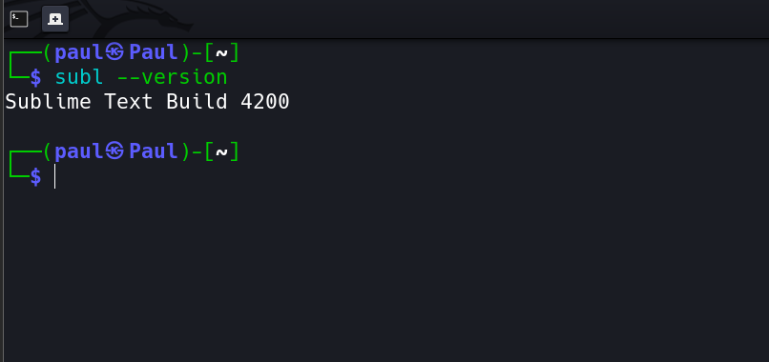

4. Opening the .eml File in Sublime Text

From the Terminal
subl 01_Phishing_Analysis/Challenges/challenge3.eml

From the Sublime Text GUI
- Launch Sublime Text from the applications menu, or type subl in your terminal
- Press Ctrl+O (File > Open File)
- Navigate to 01_Phishing_Analysis/Challenges/ and select challenge3.eml

💡 NOTE: Opening a .eml file in Sublime Text is entirely safe. It reads the file as plain text and will not parse, render, or execute any embedded HTML, scripts, links, or macro content.

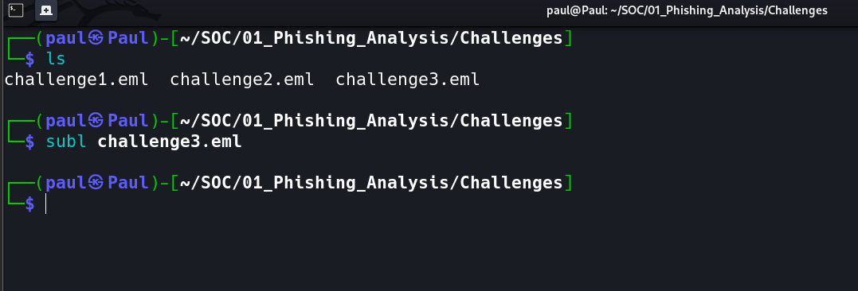

5. Navigating the .eml File in Sublime Text

The .eml file has two distinct sections separated by the first blank line:

- Section 1 — Headers: Everything above the first blank line. A block of Key: Value metadata pairs.
- Section 2 — Body & Attachment: MIME-encoded email body and base64 attachment data below the headers.

Ctrl+F Search Cheat Sheet
Use Ctrl+F to jump directly to any field. Press Enter to cycle through multiple matches.

Search Term (Ctrl+F) | Field Located | Answers Question
Date: | Delivery timestamp | Q1
Subject: | Email subject line | Q2
To: | Recipient name and address | Q3
From: | Sender display name + address | Q4 & Q5
Received: | Mail server routing chain | Q6
X-Mailer: | Sending client / infrastructure | Q6 (supplementary)
Message-ID: | Unique email identifier | Q7
filename= | Attachment filename in MIME | Q9

🔵 SUBLIME TIP: Press Ctrl+F, type Received, then hit Enter repeatedly to step through every Received: header. The bottom-most match is the true origin server — work up from there.

6. Email Header Analysis

Q1 — Date and Time of Email Delivery
Based on the contents of the email header, what is the full date and time of the email delivery?

✅ ANSWER: : Tue, 14 May 2024 23:31:08 +0000

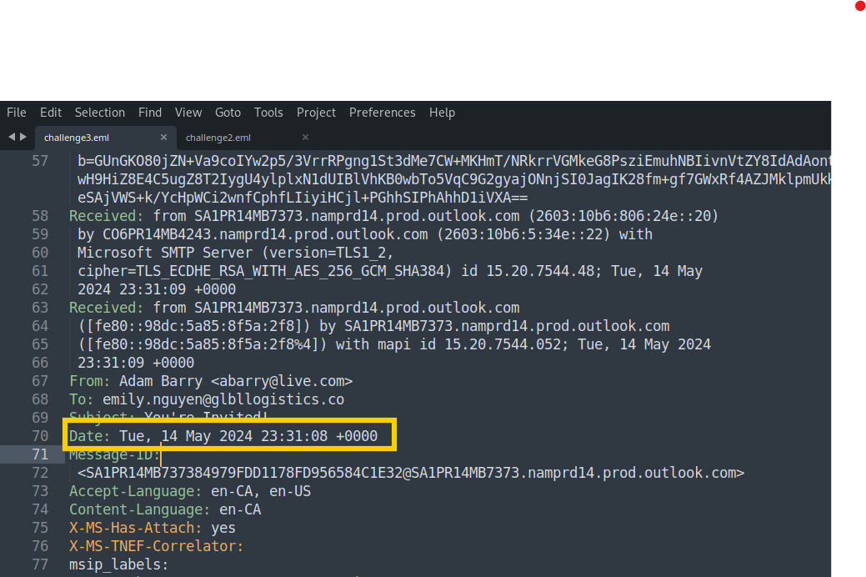

Q2 — Email Subject
What is the subject of the email?

💡 NOTE: Phishing subjects are engineered for urgency or familiarity — "Hey! Look at this", "Your invoice is ready", "Important update". The subject is a primary social engineering hook.

✅ ANSWER: You're Invited!

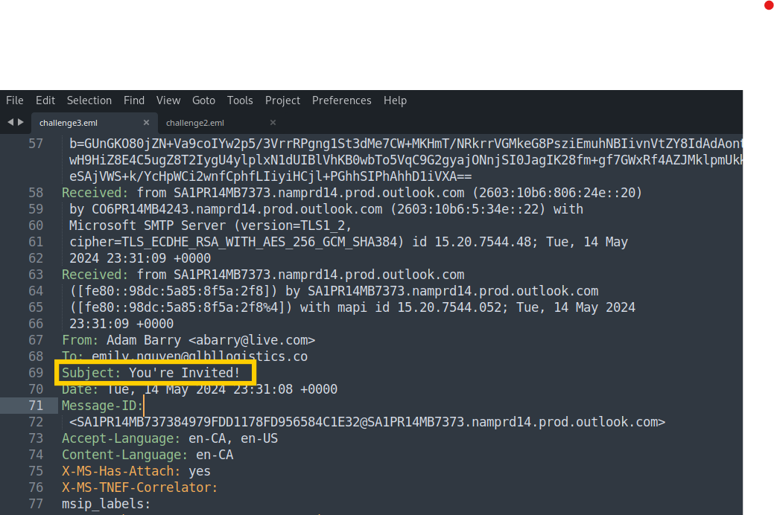

Q3 — Email Recipient
Who was the email sent to?

✅ ANSWER: emily.nguyen@globallogistics.co

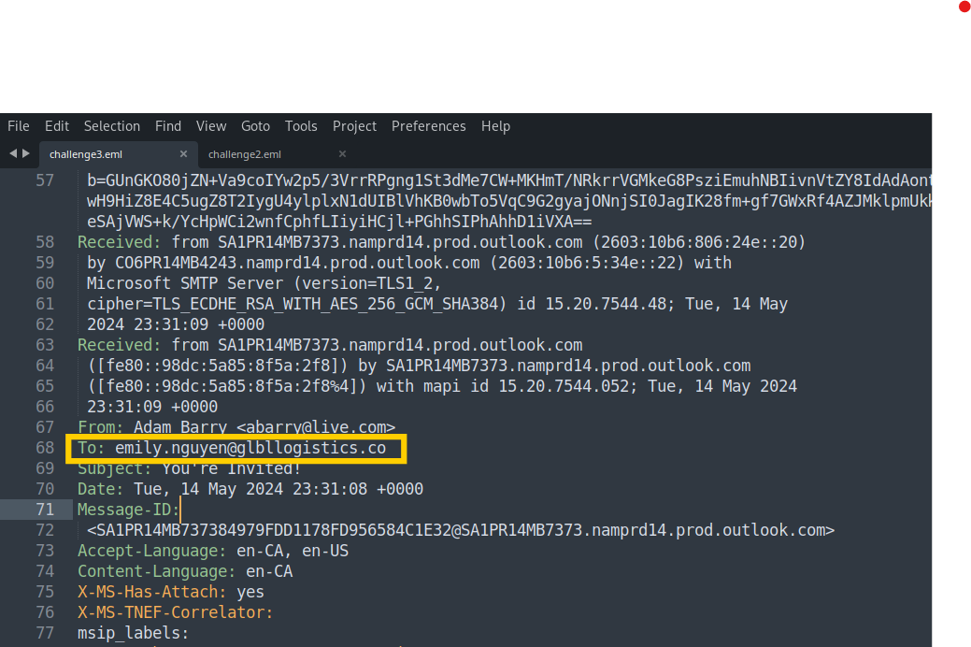

Q4 — Claimed Sender (Display Name)
Based on the sender's display name, who does the email claim to be from?
Q5 — Actual Email Address
What is the sender's email address?

Part of From: Field | What It Is | Question
Alexia Barry | Display Name — what Emily sees in her inbox | Q4
<attacker@some-domain.com> | Actual sending address — the attacker's real address | Q5

⚠️ RED FLAG: The display name can be set to anything by the sender. Attackers abuse this to impersonate trusted contacts. Emily sees "Alexia Barry" — but the real address exposes the truth.

✅ ANSWER: Q4: Adam Barry

✅ ANSWER: Q5: abarry@live.com

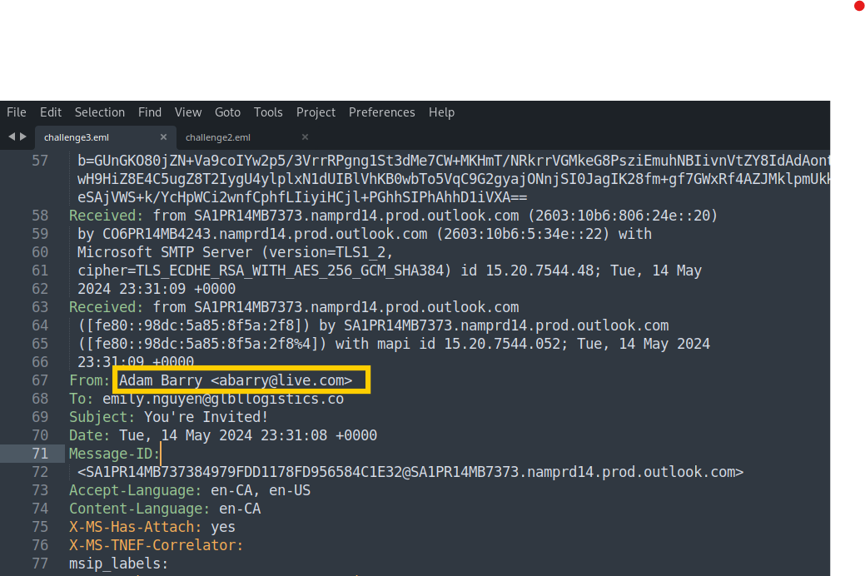

Q6 — Email Infrastructure / Provider
What email infrastructure or provider was used to send the email?

Header Pattern Seen | Sending Infrastructure
smtp.gmail.com / mail.google.com | Google Gmail
smtp.mail.yahoo.com | Yahoo Mail
mail.protonmail.ch | ProtonMail
sendgrid.net | SendGrid (bulk/transactional email)
amazonses.com | Amazon Simple Email Service

⚠️ RED FLAG: A legitimate corporate email routes through the company's own mail servers. Finding a free consumer provider like Gmail here is a definitive sign of spoofing.

✅ ANSWER: Microsoft

To get the email infrastructure provider, check for the IP and Port of the sender (check Line 31) then run this command on your kali machine.

whois 2a01:111:f403:2c14::801

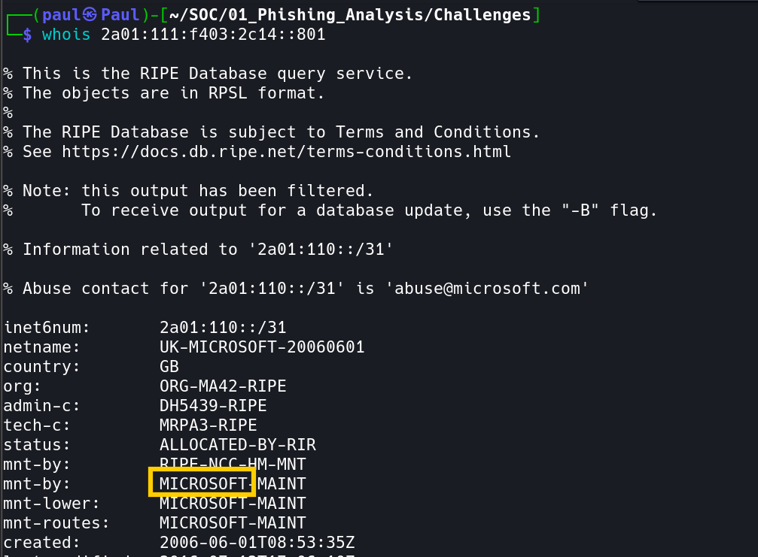

Q7 — Message ID
What is email's Message ID?

Message-ID: <CABxxxxxxxxxxxxxxxx@mail.gmail.com>

🔵 SUBLIME TIP: The domain after @ in the Message-ID (e.g., mail.gmail.com) independently confirms the sending platform — a second data point that corroborates what you found in the Received: headers.

✅ ANSWER: <SA1PR14MB737384979FDD1178FD956584C1E32@SA1PR14MB7373.namprd14.prod.outlook.com>

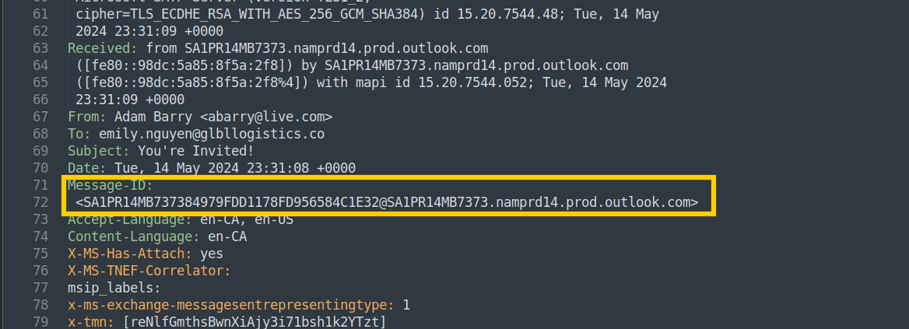

7. Attachment Analysis with emldump.py

While Sublime Text shows the raw MIME structure, emldump.py is the correct tool for safely extracting the attachment without triggering any embedded content. Open a terminal alongside Sublime Text and run:

This is located on Line 146: AR_Wedding_RSVP.docm

💡 NOTE: You will have already spotted the filename in Sublime Text by searching for filename= in the MIME headers. emldump.py confirms this and provides the index number needed for safe extraction.

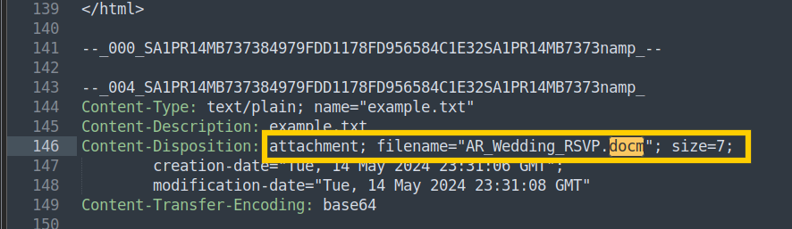

Q8 — Attachment Index Number
The index number is the first value on the line that shows a document MIME type (e.g., application/vnd.ms-excel) alongside a filename. Record this number — it is used in the next extraction step.

First extract the attachment using emldump.py script.

python3 emldump.py challenge3.eml

✅ ANSWER: 5

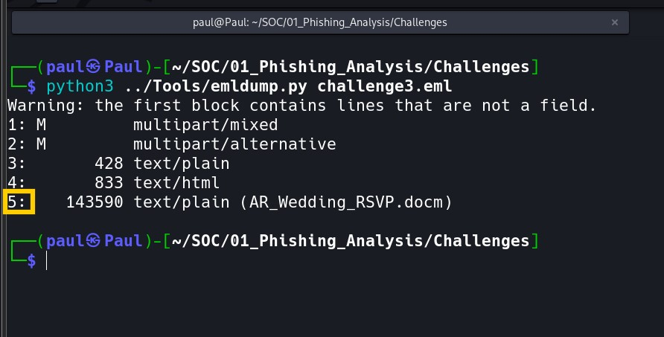

Q9 — Attachment Filename
The filename appears immediately after the MIME type in the emldump.py output. Record the exact name including its file extension.

⚠️ RED FLAG: Extension alert: Malicious Office documents (.xls, .xlsm, .doc, .docm) frequently contain embedded VBA macros that execute automatically on open. Double extensions like "invoice.pdf.xls" are also used to deceive recipients.

✅ ANSWER: AR_Wedding_RSVP.docm

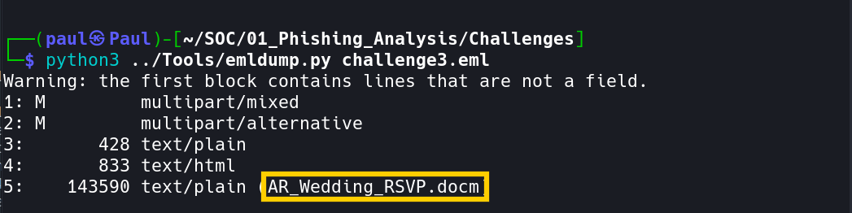

8. Cryptographic Hash Analysis

Use emldump.py to extract the attachment by its index number, then generate its SHA-256 hash. Replace 4 with the index number you identified in Q8, and replace the filename with your actual attachment name:

# Extract the attachment safely (replace 4 with correct index)
$ python3 emldump.py challenge3.eml -s 5 -d > AR_Wedding_RSVP.docm

# Generate the SHA-256 cryptographic hash
$ sha256sum AR_Wedding_RSVP.docm

# Example output:
3395856ce81f2b7382dee72602f798b642f14140d239604e8013d54a7f7e3b3b AR_Wedding_RSVP.docm

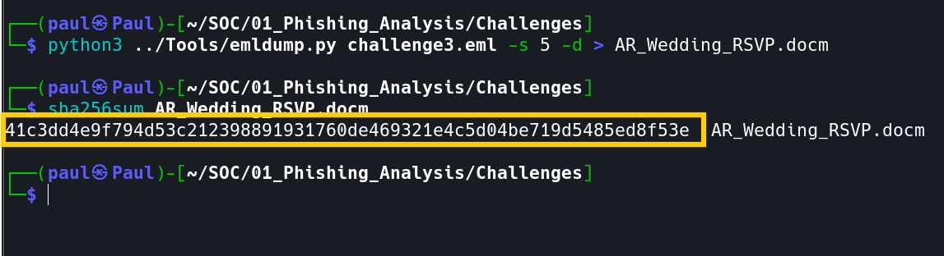

Q10 — SHA-256 Hash
What is the SHA-256 hash of the attachment?
The SHA-256 hash is the 64-character hexadecimal string output by sha256sum. Its role in SOC work:

- Unique fingerprint: even a single-byte change produces a completely different hash
- Threat intel lookup: search VirusTotal and other platforms for known detections
- IOC creation: block the exact file on all endpoints using the hash as a signature
- Evidence integrity: proves the extracted file has not been altered since extraction

✅ ANSWER: 41c3dd4e9f794d53c212398891931760de469321e4c5d04be719d5485ed8f53e



9. VirusTotal Threat Intelligence

Navigate to https://www.virustotal.com, click the Search tab, paste the SHA-256 hash, and press Enter. VirusTotal checks the hash against 70+ antivirus engines and returns a full threat profile.

VirusTotal Field | What It Means
Detection Ratio | e.g., 42/72 — proportion of engines that flagged the file
Popular threat label | Consensus malware classification name across all vendors
File Type | True format of the file (may differ from the extension)
First Seen | When this exact sample was first submitted to VirusTotal
Last Analysis | When the most recent multi-engine scan was performed

Q11 — Popular Threat Label
Submit the hash value to VirusTotal. What is the Popular threat label returned for this sample?

The Popular threat label at the top of the results page is VirusTotal's consensus classification — the most commonly agreed-upon malware name across all contributing antivirus vendors. Common labels for malicious Office documents:

- trojan-downloader.vba.agent — VBA macro that fetches and executes a secondary payload
- macro.downloader — Generic malicious macro downloader classification
- trojan.agent — Generic trojan family

✅ ANSWER: trojan.autdwnlrner/w97m

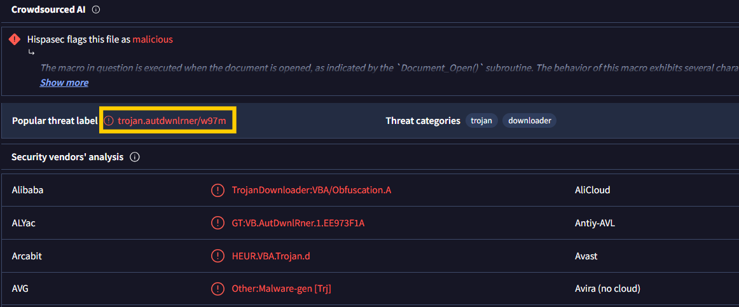

10. Final Determination

Q12 — Should the Email Be Released?
Finding | Severity | Evidence
Display name spoofing | CRITICAL | From: display name does not match actual sending address
Infrastructure mismatch | CRITICAL | Email routed via personal/free provider, not corporate mail
Unexpected attachment | HIGH | File attached with no legitimate business justification
Malicious file confirmed | CRITICAL | SHA-256 hash flagged by multiple engines on VirusTotal
VBA macro payload | CRITICAL | Office file type associated with macro-based malware delivery

🚨 VERDICT: NO — DO NOT RELEASE. This is a confirmed phishing attack with a malicious attachment. Maintain quarantine and escalate immediately.

Recommended Response Actions
- Maintain email quarantine — do not release to Emily's inbox under any circumstances
- Block the sender's email address and sending domain at the gateway
- Submit all IOCs (hash, sender address, domain) to your threat intelligence platform
- Notify Emily Nguyen that a phishing email impersonating Alexia Barry was intercepted
- Search mail logs for similar emails delivered to other staff members
- If Emily had any prior contact with this sender, check her endpoint for signs of compromise

11. Bonus — Static VBA Macro Analysis

oletools provides a suite of Python tools for safely analyzing malicious Microsoft Office documents without executing them. Oledump.py specifically extracts and decompiles embedded VBA macros for static review.

# Run oledump.py against the extracted file to see all internal OLE streams:
$ python3 oledump.py AR_Wedding_RSVP.docm

# Extract the stream marked with M using the -s flag (stream number) and -v to decompress/decode the VBA:
$ python3 oledump.py AR_Wedding_RSVP.docm -s A3 -v

In the macro-output, look for these critical patterns:

VBA Pattern | What It Does
URLDownloadToFile | Windows API — downloads a remote file to a local path on disk
Shell / WScript.Shell | Executes a system command or runs the downloaded payload
http:// or https:// | Hardcoded attacker-controlled download URL
Environ("TEMP") | Drops payload to the user's Temp directory to avoid suspicion
AutoOpen / Auto_Open | Macro runs automatically when the document is first opened

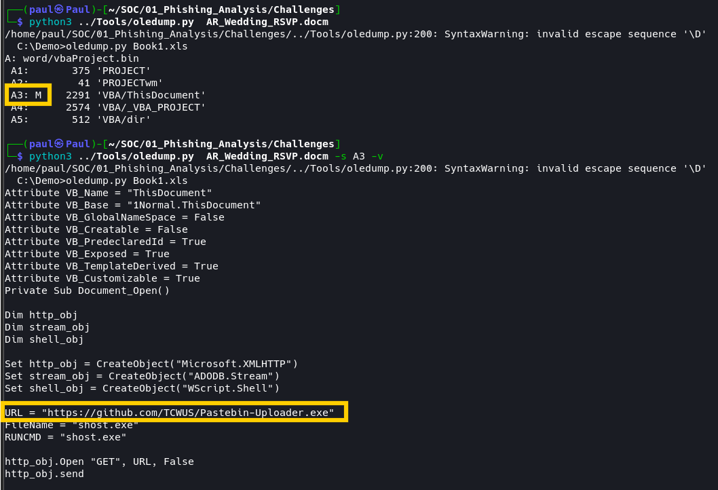

Bonus Q1 — Download URL (Defanged Format)
Locate the URL inside the URLDownloadToFile call in the oledump.py output, then defang it before including in your report to prevent accidental navigation:

URL = https://github.com/TCWUS/Pastebin-Uploader.exe

To defang the URL, I used Cyber Chef by searching and dragging the “Defang URL” then copying and pasting the URL and it will be defanged automatically

✅ ANSWER: hxxps[://]github[.]com/TCWUS/Pastebin-Uploader[.]exe

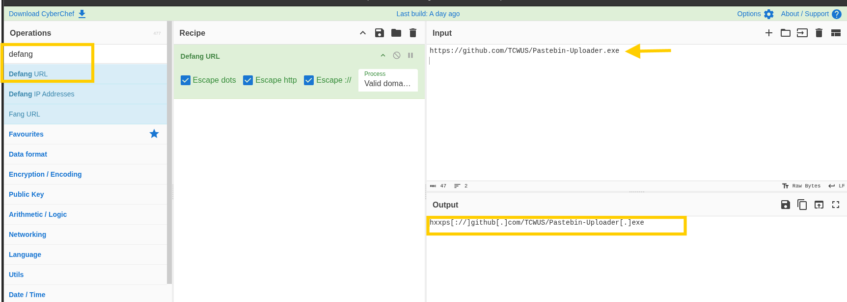

Bonus Q2 — Executable Filename
The second argument to URLDownloadToFile specifies where the payload is saved locally. Look for the path string:

In the example above, update.exe is the filename. Attackers typically use generic Windows-sounding names (svchost32.exe, winupdate.exe) to blend in with legitimate system processes.

✅ ANSWER: shost.exe

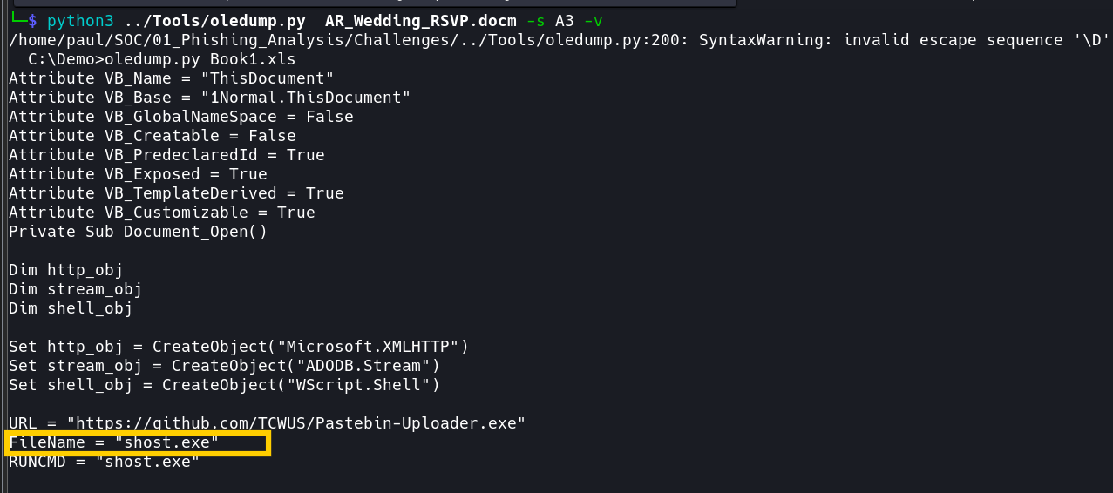

12. Indicators of Compromise (IOC) Summary

IOC Type | Value
Sender Display Name | Adam Barry
Sender Email Address | abarry@live.com
Email Subject | You're Invited!
Sending Infrastructure | Microsoft
Message-ID | <SA1PR14MB737384979FDD1178FD956584C1E32@SA1PR14MB7373...
Attachment Filename | AR_Wedding_RSVP.docm
SHA-256 Hash | 41c3dd4e9f794d53c212398891931760de469321e4c5d04be…
VirusTotal Threat Label | trojan.autdwnlrner/w97m
Download URL (defanged) | hxxps[://]github[.]com/TCWUS/Pastebin-Uploader[.]exe
Dropped Executable Name | shost.exe

13. Key Takeaways

- Always inspect raw email headers — display names are trivially spoofed and cannot be trusted at face value
- Sublime Text is an ideal safe viewer — reads .eml files as plain text with zero risk of executing embedded content
- Use Ctrl+F to navigate efficiently — searching field names is faster than scrolling through long .eml files
- Check the Message-ID domain — it independently confirms the true sending platform and exposes mismatches
- Never trust unexpected attachments — even when the sender appears to be a known and trusted contact
- Hash before analyzing — SHA-256 preserves file integrity and enables fast threat intelligence lookups
- Use oledump.py for macro analysis — never open malicious Office files directly in your local environment
- Always defang URLs and IPs — prevents accidental access when sharing IOCs in reports and team communications

SOC Analyst | Global Logistics | Phishing Analysis Challenge 3 | Kali Linux + Sublime Text

